**TASK 1:**

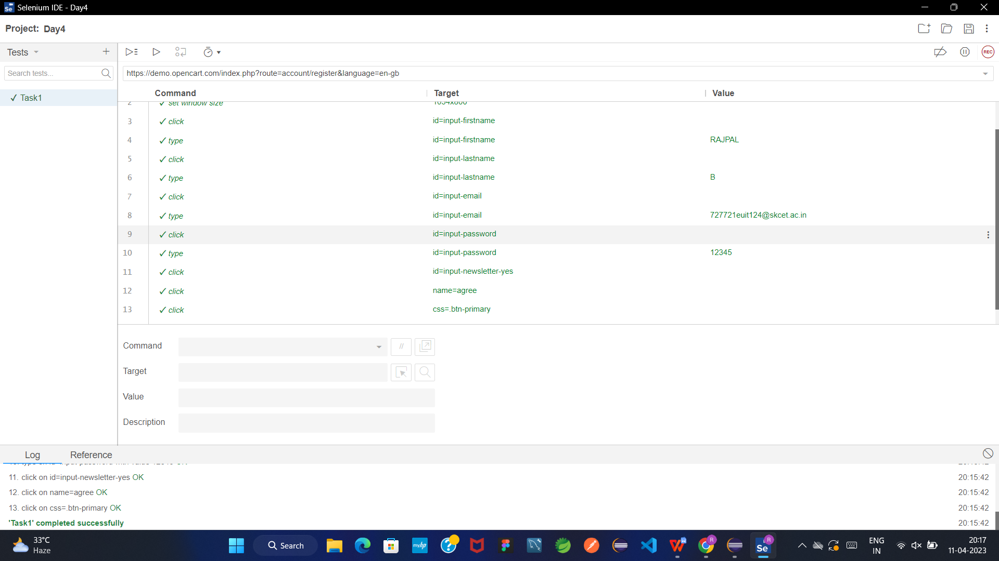

**TASK 2:**

package practice;

import org.openqa.selenium.By;

import org.openqa.selenium.WebDriver;

import org.openqa.selenium.WebElement;

import org.openqa.selenium.chrome.ChromeDriver;

import org.openqa.selenium.chrome.ChromeOptions;

import io.github.bonigarcia.wdm.WebDriverManager;

public class day4task2 {

public static void main(String args[]) {

WebDriverManager.chromedriver().setup();

WebDriver driver;

ChromeOptions co = new ChromeOptions();

co.addArguments("--remote-allow-origins=*");

driver = new ChromeDriver(co);

driver.manage().window().maximize();

driver.navigate().to("https://demo.opencart.com/index.php?route=account/register&language=en-gb");

WebElement fname=driver.findElement(By.id("input-firstname"));

fname.sendKeys("Rajpal");

WebElement lname = driver.findElement(By.id("input-lastname"));

lname.sendKeys("B");

WebElement email = driver.findElement(By.id("input-email"));

email.sendKeys("rajpal@gmail.com");

WebElement pword = driver.findElement(By.id("input-password"));

pword.sendKeys("rajpal123");

WebElement check = driver.findElement(By.xpath("//*[@id=\"input-newsletter-yes\"]"));

check.click();

WebElement terms = driver.findElement(By.xpath("//*[@name=\"agree\"]"));

terms.click();

}

}

**TASK 3:**

package practice;

import org.openqa.selenium.By;

import org.openqa.selenium.JavascriptExecutor;

import org.openqa.selenium.WebDriver;

import org.openqa.selenium.WebElement;

import org.openqa.selenium.chrome.ChromeDriver;

import org.openqa.selenium.chrome.ChromeOptions;

import io.github.bonigarcia.wdm.WebDriverManager;

public class day4task3 {

public static void main(String args[]) {

WebDriverManager.chromedriver().setup();

WebDriver driver;

ChromeOptions co = new ChromeOptions();

co.addArguments("--remote-allow-origins=*");

driver = new ChromeDriver(co);

driver.manage().window().maximize();

driver.navigate().to("https://demo.opencart.com/index.php?route=checkout/voucher&language=en-gb");

WebElement regname= driver.findElement(By.xpath("//*[@id=\"input-to-name\"]"));

regname.sendKeys("Rajpal");

WebElement regemail= driver.findElement(By.xpath("//*[@id=\"input-to-email\"]"));

regemail.sendKeys("rajpal@gmail.com");

WebElement name= driver.findElement(By.xpath("//*[@id=\"input-from-name\"]"));

name.sendKeys("Raj");

WebElement email= driver.findElement(By.xpath("//*[@id=\"input-from-email\"]"));

email.sendKeys("raj@gmail.com");

WebElement gifttheme= driver.findElement(By.xpath("//*[@id=\"input-theme-7\"]"));

gifttheme.click();

WebElement msg= driver.findElement(By.xpath("//*[@id=\"input-message\"]"));

msg.sendKeys("Happy Birthday");

WebElement amt= driver.findElement(By.xpath("//*[@id=\"input-amount\"]"));

amt.sendKeys("1000");

JavascriptExecutor js = (JavascriptExecutor) driver;

js.executeScript("window.scrollBy(0,1000)", "");

WebElement terms= driver.findElement(By.xpath("//*[@id=\"form-voucher\"]/div[8]/div/div/input"));

terms.click();

//

// WebElement con = driver.findElement(By.xpath("//*[@class=\"btn btn-primary\"]"));

// con.submit();

}

}

**TASK 4:**

package practice;

import org.openqa.selenium.By;

import org.openqa.selenium.WebDriver;

import org.openqa.selenium.WebElement;

import org.openqa.selenium.chrome.ChromeDriver;

import org.openqa.selenium.chrome.ChromeOptions;

import io.github.bonigarcia.wdm.WebDriverManager;

public class day4task4 {

public static void main(String args[]) {

WebDriverManager.chromedriver().setup();

WebDriver driver;

ChromeOptions co = new ChromeOptions();

co.addArguments("--remote-allow-origins=*");

driver = new ChromeDriver(co);

driver.navigate().to("https://j2store.net/free/");

driver.manage().window().maximize();

WebElement cloth = driver.findElement(By.xpath("//*[@id=\"Mod112\"]/div/div/ul/li[1]/h4/a"));

cloth.click();

driver.navigate().back();

driver.navigate().forward();

driver.navigate().refresh();

driver.close();

}

}

**TASK 5-1:**

package practice;

import org.openqa.selenium.By;

import org.openqa.selenium.WebDriver;

import org.openqa.selenium.WebElement;

import org.openqa.selenium.chrome.ChromeDriver;

import org.openqa.selenium.chrome.ChromeOptions;

import io.github.bonigarcia.wdm.WebDriverManager;

public class day4task5_1 {

public static void main(String args[]) {

WebDriverManager.chromedriver().setup();

WebDriver driver;

ChromeOptions co = new ChromeOptions();

co.addArguments("--remote-allow-origins=*");

driver = new ChromeDriver(co);

driver.navigate().to("https://j2store.net/free/");

driver.manage().window().maximize();

String title=driver.getCurrentUrl();

if(title.equals("https://j2store.net/free/"))

System.out.println("Title validated");

else

System.out.println("Title not validated");

WebElement cloth = driver.findElement(By.xpath("//*[@id=\"Mod112\"]/div/div/ul/li[1]/h4/a"));

cloth.click();

String clothtitle=driver.getCurrentUrl();

if(clothtitle.equals("https://j2store.net/free/index.php/shop?filter_catid=11"))

System.out.println("clothing Title validated");

else

System.out.println("clothing Title not validated");

}

}

**TASK 5-2:**

package practice;

import java.util.List;

import org.openqa.selenium.By;

import org.openqa.selenium.WebDriver;

import org.openqa.selenium.WebElement;

import org.openqa.selenium.chrome.ChromeDriver;

import org.openqa.selenium.chrome.ChromeOptions;

import io.github.bonigarcia.wdm.WebDriverManager;

public class day4task5_2 {

public static void main(String args[]) {

WebDriverManager.chromedriver().setup();

WebDriver driver;

ChromeOptions co = new ChromeOptions();

co.addArguments("--remote-allow-origins=*");

driver = new ChromeDriver(co);

driver.navigate().to("https://j2store.net/free/");

driver.manage().window().maximize();

WebElement cloth = driver.findElement(By.xpath("//*[@id=\"Mod112\"]/div/div/ul/li[1]/h4/a"));

cloth.click();

List<WebElement> li = driver.findElements(By.xpath("//*[@class=\"product-title\"]"));

for(WebElement l:li)

System.out.print(l.getText()+" ");

}

}